**COMPUTER ENGINEERING**

**Title of Micro-Project:** Micro-Project on Advantages and Disadvantages Of iPhone.

**GROUP MEMBERS**

|  |  |  |
| --- | --- | --- |
| **ROLL NO** | **CLASS** | **NAME OF MEMBER** |
| 3111 | CO6I | Shreyash Kotain |
| 3112 | CO6I | Darshana Kure |
| 3113 | CO6I | Sahil Mahatre |
| 3114 | CO6I | Omkar Moolya |
| 3115 | CO6I | Aman Pandey |
| 3116 | CO6I | Priyanka Patil |
| 3117 | CO6I | Heramb Pawar |
| 3118 | CO6I | Aditya Raut |
| 3119 | CO6I | Pawan Salve |
| 3120 | CO6I | Ameya Sawant |

**Guide Name**: - Mrs. Sharmila Wankhede

Part A Plan

**Title of Micro-Project:** Micro-Project on Advantages and Disadvantages of iPhone.

**Brief description**: -

* The iPhone is a line of [smartphones](https://en.wikipedia.org/wiki/Smartphone) designed and marketed by [Apple Inc.](https://en.wikipedia.org/wiki/Apple_Inc.) that use Apple's [iOS](https://en.wikipedia.org/wiki/IOS) [mobile operating system](https://en.wikipedia.org/wiki/Mobile_operating_system)
* iPhone is one of the two largest smartphone [platforms](https://en.wikipedia.org/wiki/Computing_platform) in the world alongside [Android](https://en.wikipedia.org/wiki/Android_(operating_system)), forming a large part of the [luxury market](https://en.wikipedia.org/wiki/Luxury_goods).
* iPhone has generated large profits for Apple, making it one of the world's [most valuable publicly traded companies](https://en.wikipedia.org/wiki/List_of_public_corporations_by_market_capitalization)
* The first-generation iPhone was described as "revolutionary" and a "game-changer" for the mobile phone industry and subsequent models have also garnered praise.
* iPhone is expensive but it offers a better performance and quality if compared to android.

**Aim** **of Micro-Project: -**

The Micro-Project Aims To: -

* Study the features of iPhone.
* Study the advantages of iPhone.
* Study the disadvantages of iPhone.
* Study about iOS Operating System and evolution of iPhone.

**Action Plan: -**

|  |  |  |  |  |
| --- | --- | --- | --- | --- |
| **Sr No** | **Detail of Activities** | **Plan start date** | **Plan end date** | **Name of Team Members** |
| 1 | Group formed according to roll no & group leaders were elected also detailed information on micro project was given |  |  | Heramb Pawar |
| 2 | Finalization of micro project as well as detailed discussion regarding topic |  |  | Aditya Raut |
| 3 | Planning of micro-project regarding, resources, software used, submission date and completing part a plan of micro – project |  |  | Darshana Kure |
| 4 | Complete analysis of design part of micro-project & distribution of module among group members |  |  | Priyanka Patil |
| 5 | Getting it finalized by the guide |  |  | Pavan Salve |
| 6 | Implementation of Project report |  |  | Sahil Mhatre |
| 7 | Presentation of 1st part of micro-project Infront of guide by each group member and Preparing of part b plan for micro-project |  |  | Aman Pandey |
| 8 | Submission of micro-project |  |  | Aditya Raut |

**Resources used: -**

|  |  |  |  |  |
| --- | --- | --- | --- | --- |
| **Sr No** | **Name Of Resources Required** | **Specification** | **Quantity** | **Remarks** |
| 1 | Computer | **Processor-**Amd  **Hard Disk-**2 Tb  **Ram-**16gb  **Operating System-**Windows 10 Pro | 1  1  1  1 | Hardware used |
| 2 | Microsoft word | MS office 2010 | -- | Software used |

**PART B**

**Aim of The Project**: Prepare A Report on Advantages and Disadvantages Of iPhone.

**Brief description**: -

* The iPhone is a line of [smartphones](https://en.wikipedia.org/wiki/Smartphone) designed and marketed by [Apple Inc.](https://en.wikipedia.org/wiki/Apple_Inc.) that use Apple's [iOS](https://en.wikipedia.org/wiki/IOS) [mobile operating system](https://en.wikipedia.org/wiki/Mobile_operating_system)
* iPhone is one of the two largest smartphone [platforms](https://en.wikipedia.org/wiki/Computing_platform) in the world alongside [Android](https://en.wikipedia.org/wiki/Android_(operating_system)), forming a large part of the [luxury market](https://en.wikipedia.org/wiki/Luxury_goods).
* iPhone has generated large profits for Apple, making it one of the world's [most valuable publicly traded companies](https://en.wikipedia.org/wiki/List_of_public_corporations_by_market_capitalization)
* The first-generation iPhone was described as "revolutionary" and a "game-changer" for the mobile phone industry and subsequent models have also garnered praise.
* iPhone is expensive but it offers a better performance and quality if compared to android.

**Aim** **of Micro-Project: -**

The Micro-Project Aims To: -

* Study the features of iPhone.
* Study the advantages of iPhone.
* Study the disadvantages of iPhone.
* Study about iOS Operating System and evolution of iPhone.

**Course Outcome Integrated:**

* Describe salient features of iPhone.
* Identify the advantages and dis-advantages of iPhone
* Justify the USP of the given product/service from marketing point of view

**Actual Procedure Followed:**

1. **Group Formation: -** EDE is a subject that helps us to develop our entrepreneurial skills. The basic aim of micro- project is to accelerate the attainment of the various outcomes in the course. In the first 2 weeks of April the subject was introduced. The syllabus as well as details of micro-project were discussed. A group of 10 members was formed and the group leaders were selected. The schedule of plan “a”,” b” & “presentation of micro-project” were finalized. The various micro-project topics related to subject were discussed our guide gave us the opportunity to select the topic of our choice.
2. **Finalization of Micro-Project: -** After attending the lectures for 2 weeks. We selected the topic for micro-project. We discussed the topic with our guide regarding the concept which we are going to apply in the project. We individually tried to explain the basic platform of project.
3. **Planning: -** After finalization of the project we started working on the project. We started the planning phase. We discussed among ourselves regarding the resources such as testing material, software requirements, etc. In this week we completed ‘part a plan’ of the micro-project which is nothing but an initial description about the project. We submitted it to the guide.
4. **Module Distribution &Analysis Part: -** Once the planning was over regarding resources, etc. We finalized the module which we will be writing. According to members we distributed the modules. We started the analysis of project.
5. **Design Part: -** In this part we focused on designing the structure of the project. We planned to apply some formatting to give an attractive look to the structure.
6. **Implementation: -** In the week we actually started the technical phase. In this phase we technically applied the formatting as decided. Each member was designing project modules which were assigned to them. Finally, the project was within the schedule time.
7. **Presentation: -** In this week we had to present the micro-project. Each member of group presented their own parts with confidence in front of guide. She asked us various queries regarding the topics. We explained her about the various components of the project. She asked us to do some changes regarding some topics.
8. **Submission: -** This week was submission week. We submitted our project along with ‘part a & b plan’ to the guide. We also submitted the hard copies and soft copies of project to the guide

**Actual Resources Used:**

|  |  |  |  |  |
| --- | --- | --- | --- | --- |
| **Sr No** | **Name of Resources Required** | **Specification** | **Quantity** | **Remarks** |
| 1 | Computer | **Processor-**Amd  **Hard Disk-**2 Tb  **Ram-**16gb  **Operating System-**Windows 10 Pro | 1  1  1  1 | Hardware used |
| 2 | Microsoft word | MS office 2010 | -- | Software used |

**iPhone**

* **What Is iPhone?**

The iPhone is a smartphone created by Apple. It was announced on January 9, 2007. The first demonstration of the iPhone was on January 29, 2007, at the Macworld Conference & Expo. iPhone utilizes a touch screen, giving it features in addition to that of a regular cell phone such as an on-screen keyboard. Additionally, because the iPhone has a full-fledged operating system (iOS) it can run millions of different software apps, available for download On the Apple App store.

With significantly more storage space, the iPhone can hold a large number of photos, videos, and songs. Internet connectivity is provided through cellular service (4G LTE) and Wi-Fi.

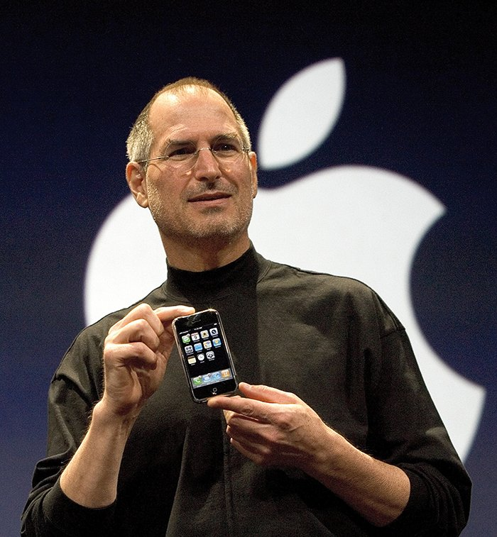

* **IOS**

iOS is a mobile operating system developed by Apple. It was originally named the iPhone OS, but was renamed to the iOS in June, 2009. The iOS currently runs on the iPhone, iPod touch, and iPad.

Like modern desktop operating systems, iOS uses a graphical user interface, or GUI. However, since it is a mobile operating system, iOS is designed around touchscreen input, rather than a keyboard and mouse. For example, applications, or "apps," can be opened by a single tap, rather than a double-click. Different screens can be viewed by swiping your finger across the screen, rather than clicking on open windows.

Since iOS is designed to be simple and easy to use, it does not include several features found in a traditional operating system. For example, you cannot manage files and folders like you can in Mac OS X or Windows. You also have limited access to iOS system settings. Instead of modifying application preferences from within each program, most settings need to be adjusted within the Settings app. Additionally, while you can run multiple programs at once, you can only view one open program at a time.

While Apple's iOS provides a more basic user interface than Mac OS X, each new version adds more features. For example, iOS 2 provided access to the App Store, which allowed users to download and install third-party apps on their iPhones. iOS 3 added copy and paste functionality and iPad support. iOS 4 was the first version to support multitasking and added the GameCenter feature. iOS 5 introduced the Siri voice assistant (only available on the iPhone 4S), and provided new cloud connectivity features

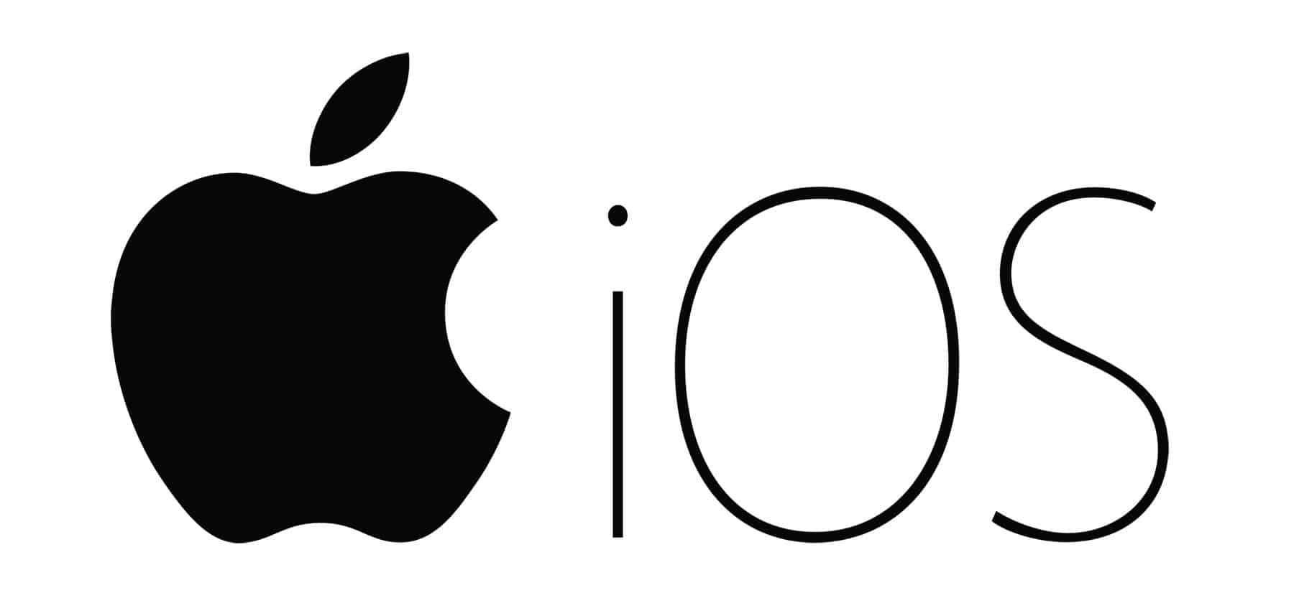

* **List of Every iPhone Models From 2007-2021:**

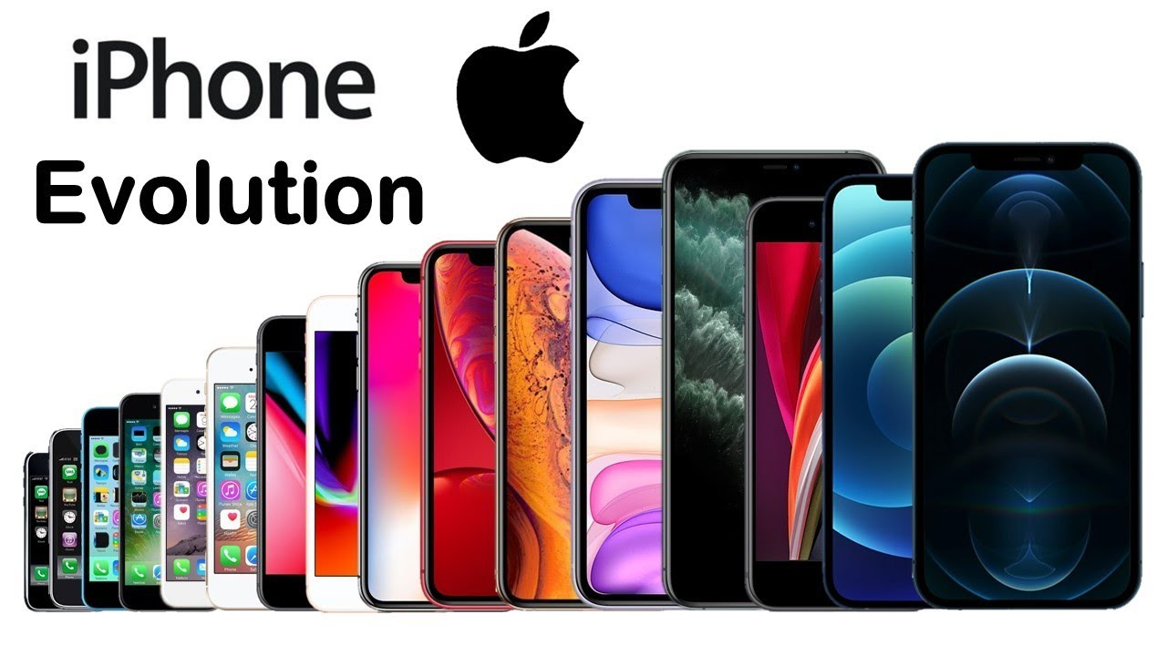

1. iPhone
2. iPhone 3G
3. iPhone 3GS
4. iPhone 4
5. iPhone 4S
6. iPhone 5
7. iPhone 5c
8. iPhone 5s
9. iPhone 6
10. iPhone 6 Plus
11. iPhone 6s
12. iPhone 6s Plus
13. iPhone SE
14. iPhone 7
15. iPhone 7 Plus
16. iPhone 8
17. iPhone 8 Plus
18. iPhone X
19. iPhone XR
20. iPhone XS
21. iPhone XS Max
22. iPhone 11
23. iPhone 11 Pro
24. iPhone 11 Pro Max
25. iPhone SE (2020)
26. iPhone 12 mini
27. iPhone 12
28. iPhone 12 Pro
29. iPhone 12 Pro Max

* **A Brief History of Iphone**

Although the first iPhone was released in 2007, the development started two years back in 2005 and was kept a complete secret. Former Apple CEO Steve Jobs came up with the idea of using the touch screen to interact with the system as most of the smartphone back then were using keypads. After the first iPhone, every year, an updated iteration of the previous phone was introduced.

The second iPhone (iPhone 3G) came with GPS, 3G data, and tri-band. Similarly, features like better camera quality, voice control, quad-band, voice assistant Siri, better speakers, fingerprint scanners, IPS LCD, face recognition, thinner bezels, larger screens and so on were added to the new iPhones.

The new iPhone SE was the latest addition to the line releasing on April 24, 2020. The newer iPhone models have Apple Bionic chips installed; a processor powerful with a max CPU clock rate of 2.66 GHz which means they can run 2.66 billion instructions per second.

However, that is not enough for anyone to decide whether to buy an iPhone or go with Android. You might want to consider reading about the pros and cons of iPhone before getting one. So, here are some advantages and disadvantages of iPhone.

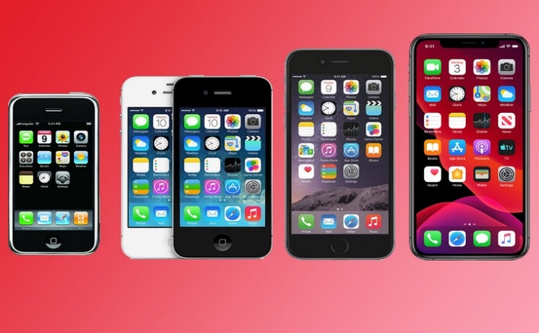

* **Advantages of iPhone**

**1. Apple Ecosystem**

iPhone is the ideal phone if you have other Apple devices such as MacBook’s, Apple Watch, or iPads. Connecting one device with another is seamless and very convenient. This is really handy if you have to transfer files or photos from your phone to your laptop or vice versa. Apple IOS and macOS have developed to the level where you can start a movie in your phone and continue it later on your laptop.

**2. Something for Everyone**

Two years back, a new iPhone would cost you up to $1200 which is crazy for a phone. However, things have changed a lot now. You can get the new iPhone SE for $400 or a new iPhone 11 for $700 or a new iPhone 11 pro for $900 and they all come with the same A13 bionic processor. This gives you various options to choose from and you will not have to break your bank to buy a phone.

**3. iCloud**

iCloud is a cloud storage service from Apple. When turned on, it can automatically save all your files and photos to the cloud as a backup in case your device gets lost or stolen. Also, you can access it with your email anywhere with internet access. This is really helpful and you won’t need your pen-drive or any secondary storage device as everything’s backed up in the cloud.

**4. Easy User Interface**

iPhones have a simple interface and the similarity of the UI between the apple devices make it really easy to operate. The iPhone ensures all apps and functions are being performed the way Apple intends them to, which allows for simple user experience. While android has more freedom and choices, users find it comparatively difficult to use.

**5. Faster Processor**

Let’s compare Samsung Galaxy S20 Ultra with iPhone X, the best android phone available in the market right now, and almost a 3-year-old iPhone. The geek-bench score for a single core of iPhone is equal to that of Samsung.

Tech experts say that iPhone’s processor will always be two steps ahead of android. The newest iPhone has a single-core geek bench score of 1337, 432 more than the S20. This proves that iPhones have better, faster processors than their competitors.

**6. Fewer Security Breaches**

While you have the freedom of customization on an Android, it might be costly. Android phones are easy to access and hackers can corrupt your files or even steal your personal information. With the iPhone, things like this are very rare as everything has to first go through Apple’s firewall. However, you should always check before downloading anything from a third party.

**7. iPhone Privileges**

Getting an iPhone also means you’ll be able to use various Apple only features like Apple pay, Apple Car play, FaceTime, iMessage and so on. The popularity of the iPhone has increased priority to the IOS apps. There are many apps like Apollo and Drafts which are not available to Android.

**8. Frequent Software Updates**

Apple continuously provides software updates to its old iPhones. Even if it is a five years old iPhone, you will get an update. Compare that to Samsung. Samsung stops providing software updates after only 18 to 24 months.

**9. High Build Quality**

From day one, every iPhone’s build quality is excellent. It’s glass, and metal design shows you how premium an iPhone is.

* **Disadvantages of iPhone:**

**1. Expensive**

iPhones are overpriced. Even an iPhone that came two years ago is more costly than a new high-end Android flagship device. Yes, iPhone’s user experience and hardware integration with the software are better than android phones. But this does not justify the high iPhone prices.

**2. No Headphone Jacks**

Though more OEMs are adopting this no headphone jack trend, still having a 3.5mm headphone jack makes life easier. iPhone comes with only one lighting port. I can either charge the iPhone or listen to music. You can’t do both at the same time. You can use an AirPods, but that is expensive. The lowest-priced Airpod costs $160. Third-party Bluetooth headphones are pricey too.

**3. No External Storage**

On the iPhone, you can’t use an SD card. No iPhone has an SD card slot. Even if you connect an SD card reader with your iPhone and insert an SD card, your iPhone would not allow you to transfer any documents, and media files except only photos.

**4. No External Apps**

You have to install each App from Apple Appstore. There is no legal way to download and install an App from the internet other than Apple Appstore. For example, in Android, if an app is banned from google play store but you need the app, you can download the app APK from a trusted source and install it. You can also install a third-party app store, for example, Amazon AppStore, which has hundreds of thousands of apps. In the iPhone, it’s not possible.

**5. Expensive Accessories**

There’s no doubt that iPhone accessories are costly. Airpods, phone cases, Apple pencil, lightning cable, etc. anything that is made by Apple is high-priced.

**6. Not Customizable**

An android phone is highly customizable. Installing custom ROM and rooting an android device is very easy. Moreover, a third-party app, custom launcher, and widget installation is straightforward. On the iPhone, all these things are not possible. iPhone’s widget system is inferior. Rooting an iPhone — jailbreaking — is extremely hard. In short, the iPhone is not customizable at all.

**7. Repair**

iPhone repair is expensive. A simple screen replacement on the iPhone would cost you hundreds of dollars. Take a look at the list of screen replacement costs from the Apple Website.

* **Conclusion**

Similar to everything, the iPhone also has its pros and cons. But the advantages of the iPhone outweigh the cons. iPhones are great smartphones and can certainly be a great choice for you. The iPhone gives a superior user experience that no one provides. That’s why I believe the iPhone is the best phone in the world.

**References:**

We do have used a few references during the process of building our project. The references used are from Websites, Books etc.

The references used are:

* **Websites:**

1: www.apple.com

2: [www.en.wikipedia.org](http://www.en.wikipedia.org/wiki/Operating)

3: www.gadgets.ndtv.com

* **Reference Books:**

1: Product Design and Manufacturing.

2: Apple Confidential 2.0

**Skill Developed/Learning Out of This Micro Project:**

* Since we worked in a group, we developed the skill of ‘TEAMWORK’ in us.
* We learnt about the various features of iPhone.
* We learnt in brief about the various advantages and disadvantages of iPhone.